horizontal line **Food Fetch LLP**

Food Fetch

**August-September 2017**

# OVERVIEW

The digital economy continues to be in flux and is driven by user interactions instead of older, traditional methods. People want more options and personal time has become more important in this new digital paradigm of services on demand.

Food Fetch is a business plan to piece together a growing, sustainable business brought together in this digital world and uniting these users, suppliers, delivery employees and support staff to make this all feasible.

The Web App will be concerned with a food delivery company. This company would act as a courier service between the restaurants and the customers. The web site will handle the customer requests by allowing customers to sign up for the service, browse the menus of each of the restaurants and place an order for food to be delivered as soon as possible.

The web site will require a front end for customer sign up and order placement and it will require a back end which tracks all the customers, orders, restaurants and employees.

# Business Case

1. Offering increased, public services which will lead to user supplied data and monies connecting to increased services and delivery options provided by user employees.
2. ‘Gig economy’ improved over time? (<https://theunlikelylawyerblog.wordpress.com/2017/05/22/the-gig-economy-and-the-case-against-deliveroo/>) [(https://www.fastcompany.com/3066905/how-the-gig-economy-will-change-in-2017/)](https://www.fastcompany.com/3066905/how-the-gig-economy-will-change-in-2017/)) [NYTimes opinion False Hope of Gig economy](https://www.nytimes.com/2017/04/10/opinion/the-gig-economys-false-promise.html)
3. There are a lot more options than pizzas and burgers today. Food Fetch aims to provide a vastly increased food selection (by finding nearest restaurants that are open, by finding employees that are willing to work to deliver at that specific time of day or night, by increasing services to offer foods by types -[breakfast, lunch, dinner, or pre-made sandwiches or rolls, or cakes and pastries for social parties, or maybe ethnicity like Mexican, American, Indian, Brazillian, French, Italian, German, Spanish, Japanese, Chinese, South-East Asian like Vietnamese, Thai. )
4. Need Web App and 3-4 mobile apps using Ionic (based on Web views so slower but proven) or Flutter (using native code on Android and iOS to design and run on both platforms). There are other options for frameworks but Ionic or just Bootstrap might be enough for the mobile presence sought.
5. The 3-4 mobile apps are 1, Customers/Users, 2, Suppliers/Restaurants, 3, Deliverers, 4, Admin and Banking.

# Topic and Objectives of your Web Application

This website is a clone of many of the new startups operating in the gig economy. The particular models chosen were Deliveroo (Deliveroo.ie) and Just Eat (just-eat.ie) as they are current models that are in world-wide expansion trajectories and are creating new jobs directly in the Irish economy through ‘loss-leading’ establishment investments.

# Target Audiences

## Hungry People!

People need to eat! They days of simply ordering a pizza for delivery are no longer appealing. People want choices and flexibility in fast, efficient, accountable deliveries.

Getting a business foothold in this section of the economy is crucial as often these people exhibit higher return and reuse tendencies when happy with more options and delivery successes.

## People Planning Social Events

People holding social events (like birthday parties, small social gathering at offices, etc.) don’t have time to focus on food preparations. They can order online from certain companies and Food Fetch can do the delivery work.

## All ages - Young and Old

It’s too easy to target the younger generations as they are clearly the ones with the itchy fingers and an ‘always on/connected’ 3-4G mobile. They are often connected with digital/online banking; credit/debit cards, paypal, alipay, cryptocurrencies. ~’The eBay and Amazon’ mindset?

We should try for mid-lifers (bringing up families and not having time to prepare food every night of the week.) etc. Special occasions and celebrations.

We should try older people - retirees - who want to try new experiences from new restaurants or just want their tradition, trusted restaurant food delivered. They will likely do more ordering through the website than through a mobile all.

# Structural Diagram / Site Hierarchy

|  |  |  |  |
| --- | --- | --- | --- |
| **Site** | **Controller** | **Action** | **Pages** |
| Web  Site |  |  |  |
|  | Index |  |
| Home |  | Personal Information |
| SignUp |  |
|  | Payment Information |
|  | SignIn |  |
|  |  |  |
|  | About |  |
|  |  |  |
| Info | Contact |  |
|  |  |
| SiteMap |  |
|  |  |  |
|  | PrivacyPolicy |  |
|  |  | Page 1 |
|  | Restaurants | Page 2 Etc. |
|  |  |  |
| Menu | Food | Page 1 |
|  | Page 2 Etc. |
| Restaurant Map |  |
|  |  |  |
|  | Order |  |

# Visual Design (inc layout, fonts, colour scheme, screen resolution, etc.)

* Are we good enough just using CSS and maybe some SASS?
* What can we do with included Bootstrap. Do we want to use all of Bootstrap and include the JS and JQuery libraries (which make the app slower to load) or shall we just use (the must lighter) CSS and SASS engine of Bootstrap that’s only 22Kb to include and download for our website?
* What about more complicated but advanced frameworks like Angular 2/4?

# Database Design (ERD) and use

Using Dominick’s ERD here. Subject to minor changes through building application.

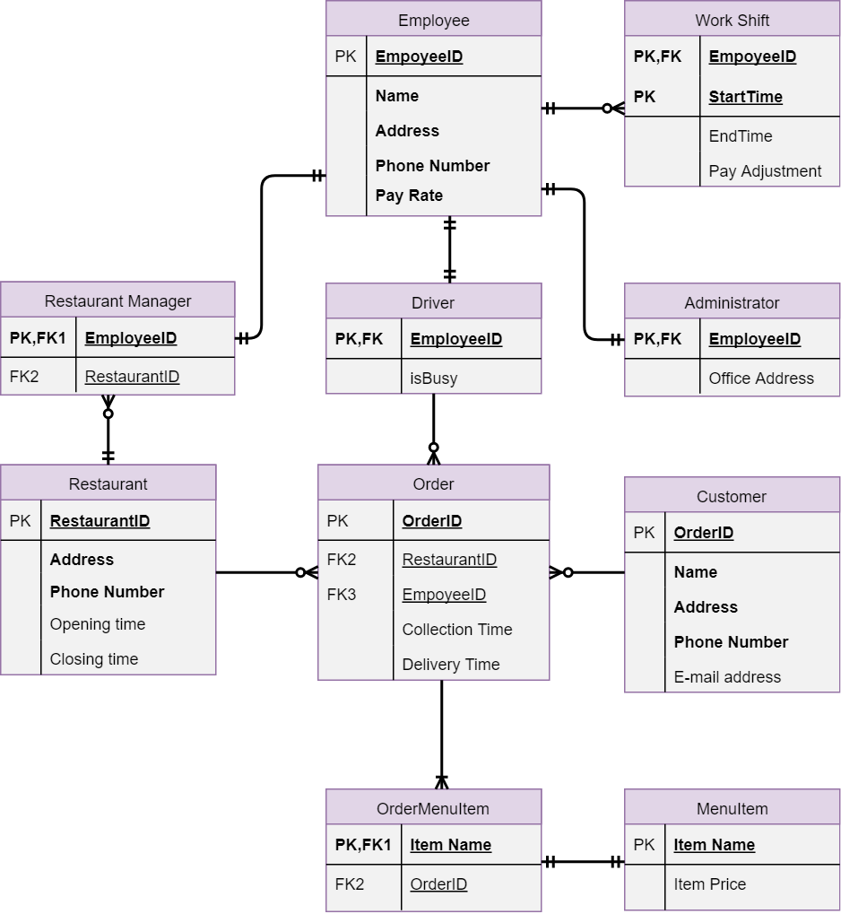

# 

# XML as a database (native, hybrid)

## Native

Use code that will be given in class and related to C# or .Net?

Try an Open-Source cross-platform XML database manager like BaseX? <http://basex.org/> Looks like it makes XML management easier.

In the end, a simple XML file was all that was needed to provide fast storage and retrieval of knowledge. Please see accompanying document “XMLdbImplementationDoc.docx” for more technical details.

# Technologies/Techniques used

This is initial design of web app and is going to be the first introduction to all possible users, suppliers and deliverers.

Possible need to make 3 additional Android apps for about 60-70% of mobile market.

Could use some multiplatform apps to include the Apple iOS market. Current rate of iOS globally is about 20% of population. However, the iOS use upon this little isle is about 25-30%. Thus, a web framework like Ionic would work for these mobile apps as they would lock in about 90-95% of available users.

# Maintenance

1. Website must be largely self running and only require basic server maintenance.
2. Logs can be visited every few days in beginning but then reduced to once weekly - in an ideal world.

# S.E.O. Search Engine Optimisation

Make sure proper references in <head> section for SEO engine.

Make sure that all photos and images have <alt> tags for SEO’s and people with Disabilities.

Make page navigable using Tab button only?

* Keywords
* Page Titles
* Heading Tags
* Description
* Description Meta Tag
* Linking
* Images & Multimedia
* XML Sitemap (un-accesed by webpage visitors)
* Pay for Advertising?
* Monitoring Search Listings?

# Strengths and Weaknesses of your Web Application

## TIme Constraints

Unfortunately, as a team, we were unable to complete all of the required syllabus. I believe this was a matter of time and not an ignorance of the technologies involved in completing this project.

Thus, this website has been a valuable lesson to all 3 of us involved and I’m sure will be looked upon again with all of the technologies involved and the most suitable ways to implement them.

# References/Bibliography

Search Engine Optimization:

* Web Development and Design Foundation with HTML5 Terry Ann Fellke-Morris, 8th Edition, Pearson, p567
* SEO Internet & World Wide Web How to Program, Deitel & Deitel, 4th Edition, Pearson p59.

# SEO link <http://www.codedigest.com/Articles/ASPNET/406_Search_Engine_Optimization_(SEO)_Tips_for_ASPNet_Sites.aspx>

# [Below is just a copy of template to be used later if needed ]

# XML as a database (native, hybrid)

## Native

Lorem ipsum dolor sit amet, consectetuer adipiscing elit, sed diam nonummy nibh euismod tincidunt ut laoreet dolore magna aliquam erat volutpat.

## Hybrid

Lorem ipsum dolor sit amet, consectetuer adipiscing elit, sed diam nonummy nibh euismod tincidunt ut laoreet dolore magna aliquam erat volutpat.

# Technologies/Techniques used

Lorem ipsum dolor sit amet, consectetuer adipiscing elit, sed diam nonummy nibh euismod tincidunt ut laoreet dolore magna aliquam erat volutpat. Ut wisi enim ad minim veniam, quis nostrud exerci tation ullamcorper.

# Maintenance

1. Lorem ipsum dolor sit amet, consectetuer adipiscing elit
2. Sed diam nonummy nibh euismod tincidunt ut laoreet dolore magna aliquam erat volutpat.

# S.E.O. Search Engine Optimisation

Nam liber tempor cum soluta nobis eleifend option congue nihil imperdiet doming id quod mazim placerat facer possim assum. Typi non habent claritatem insitam; est usus legentis in iis qui facit eorum claritatem. Investigationes demonstraverunt lectores legere me lius quod ii legunt saepius.